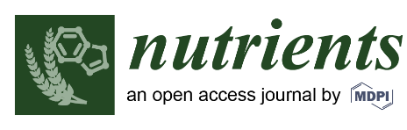

NUTRIENTS YOUNG INVESTIGATOR AWARD APPLICATION TEMPLATE

CONFIRMATION OF ELIGIBILITY
Were you ≤ 35 years of age as at 31 August 2018?
Yes
No
If you answered no to this question you are not eligible to apply for this award.
If you answered yes to this question please provide evidence of your date of birth as an attachment to your application (e.g. copy of current drivers licence, copy of relevant page of passport etc. Applications that do not have this accompanying documentation will not be considered.)

ASSESSMENT CRITERIA
Please address the following assessment criteria within a 4-page limit. Applications must be single-sided, double-spaced, Times New Roman 12 point font with at least 2.5 cm margins. Applications that are more than 4 -pages or that do not adhere to the selection/application criteria and formatting requirements will not be considered.

- Publication History
Please provide information on the number of, quality of and citations for articles that you have published that are relevant to human nutrition. Please include only full peer-reviewed publications, not published abstracts.

- Research Translation
Please provide information relating to translation of your research findings into changes in policy or practice that impact on human nutrition at the local, national and international level. This could include supporting evidence for health claims, patents, introduction of new foods into the market, etc.

- Other contributions and evidence of standing in the field of human nutrition research
Please provide information relating to any other contributions that you have made to the field of human nutrition research, or evidence of your standing in the field. Examples might include serving on committees of eminent societies, serving on editorial boards of relevant journals, serving on conference organizing committees, invited presentations at international conferences etc.

